**Assignment 4**

1. Write a Java code to display the following patterns

a)

* * * * *

 * * * *

  * * *

   * *

    *

CODE:-

**public** **class** OOP_Assignment_4 {

**public** **static** **void** main(String[] args) {

**int** i, j,k;

**for**(i=5; i>=1; --i){

**for**(j=i; j<=6; ++j){

System.***out***.print(" ");}

**for**(k=i;k>=1;k--) {

System.***out***.print("* ");}

System.***out***.println();

}

}}

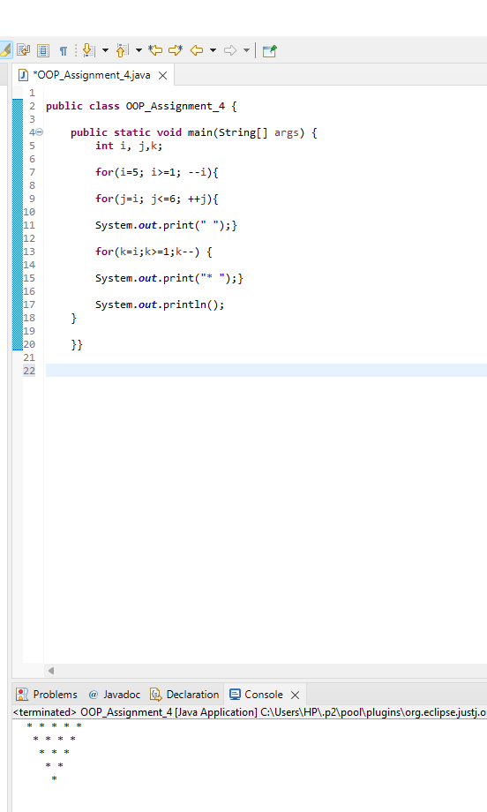

b)

*

**

***

****

*****

****

***

**

*

CODE:-

**public** **class** OOP_Assignment_4 {

**public** **static** **void** main(String[] args) {

**int** n=5;

**for** (**int** i=0; i<=n; i++)

{

**for** (**int** j=0; j<=i; j++)

{

System.***out***.print("*");

}

System.***out***.println();

}

**for** (**int** i=n; i>=1; i--)

{

**for** (**int** j=1; j<=i; j++)

{

System.***out***.print("*");

}

System.***out***.println();}

}}

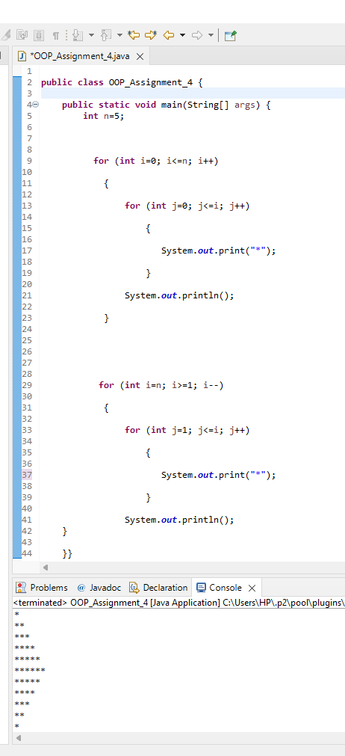

c)

*

**

***

****

*****

******

*****

****

***

**

*

CODE:-

**public** **class** OOP_Assignment_4 {

**public** **static** **void** main(String[] args) {

**int** i,j,k,l,m,n;

**for**(l=1;l<=6;++l) {

**for**(m=6;m>=l;--m) {

System.***out***.print(" ");}

**for**(n=1;n<=l;n++) {

System.***out***.print("* ");}

System.***out***.println();}

**for**(i=5; i>=1; --i){

**for**(j=i; j<=6; ++j){

System.***out***.print(" ");}

**for**(k=i;k>=1;k--) {

System.***out***.print("* ");}

System.***out***.println();

}

}}

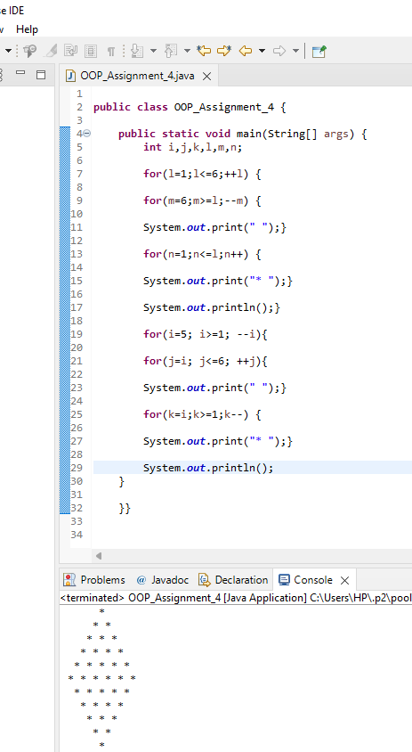

d)

*

* *

* *

* *

* *

CODE:-

**public** **class** OOP_Assignment_4 {

**public** **static** **void** main(String[] args) {

**int** i,j,k,l;

**for**(i=1; i<=5; ++i){

**for**(j=1; j<=9; ++j){

k=Math.*abs*(5-j);

**if** (k==i-1) {

System.***out***.print("*");}

**else** {

System.***out***.print(" ");}

}

System.***out***.println();}

}}

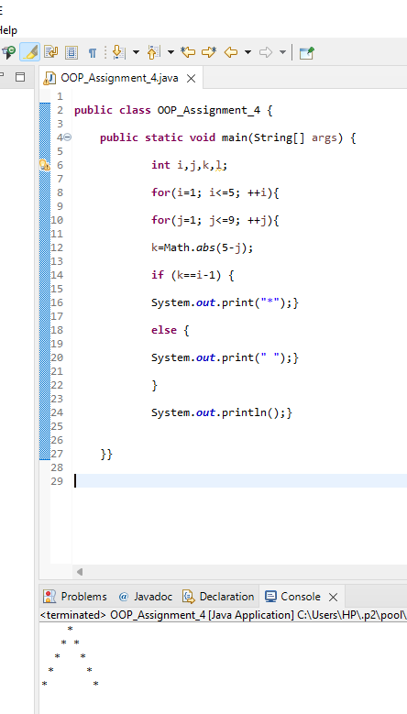

e)

* *

* *

* *

* *

*

CODE:-

**public** **class** OOP_Assignment_4 {

**public** **static** **void** main(String[] args) {

**int** i,j,k,l;

**for**(i=1; i<=5; ++i){

**for**(j=1; j<=9; ++j){

k=Math.*abs*(5-j);

**if** (k==5-i) {

System.***out***.print("*");}

**else** {

System.***out***.print(" ");}

}

System.***out***.println();}

}}

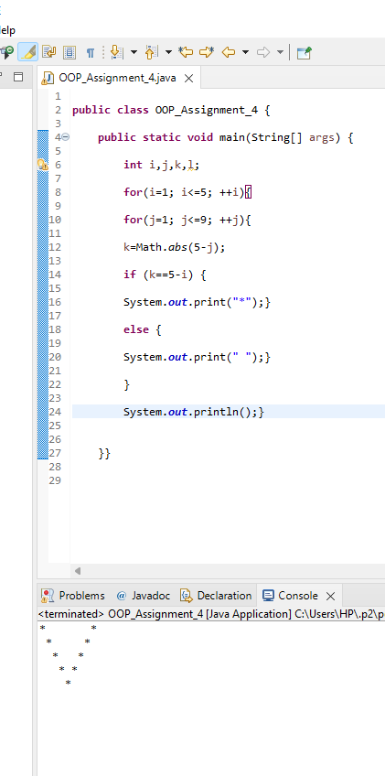

**Date & Time:** 04-12-2021, 5 PM

**Link to upload**

<https://amritavishwavidyapeetham-my.sharepoint.com/:f:/g/personal/s_sachinkumar_cb_amrita_edu/EjCcBMYIIdhIq0FxJz1urZEBXsgI8zOevoQEIlW2zt8JOw?e=EVqvAe>

Copy the code to a word document and following the below mentioned format to name the document.

**Naming format for the document:**

Batch ‘A’ students - ‘A_name.docx’

Batch ‘B’ students - ‘B_name.docx’